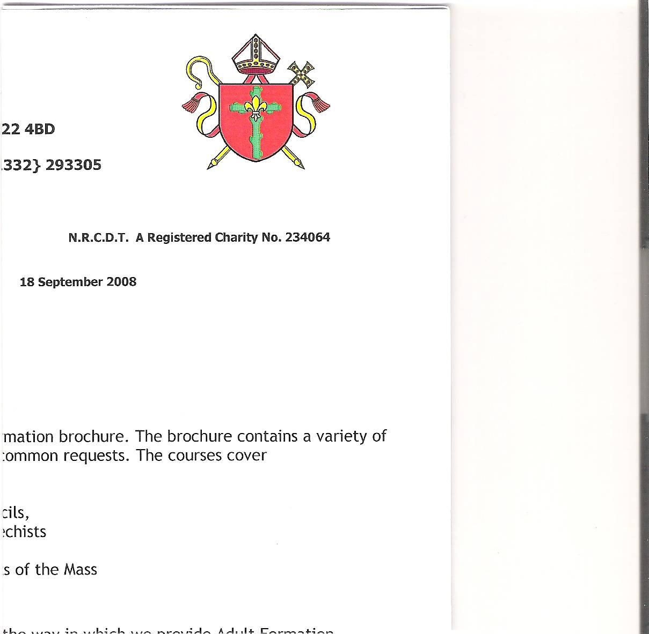

**Holy Cross Parish**

**Hucknall**

**HOLY CROSS PARISH PASTORAL COUNCIL MEETING**

**11th December 2024**

**ATTENDEES:** **APOLOGIES:**

Simon Clunie - Chair Jackie Ortega

Lauren Whitehouse – Minutes Lucas Ortega

Vivien Flynn Charles Nyarkoh

Bill Flynn

Chris Wisniewski

Sue Hanson

Vaughan Gallagher

Alex Ademiju

**WELCOME AND APOLOGIES**

Following the opening prayer by Simon, Simon welcomed everyone to the meeting and noted apologies received.

**REVIEW OF MINUTES OF LAST MEETING 11th September 2024**

The Minutes were approved as a correct interpretation of the meeting held on 11th September.

**MATTERS ARISING**

**Heating**

Vaughan provided an update on the progress. The work has now gone out to tender to five contractors. Due to the Christmas holidays, the closing date for the return of tenders is mid-January. He confirmed that all of the new heaters including the one added to the choir loft would run off the same system and that the current gas supply is sufficient for the new heating.

**Action point:** When the tenders have been returned Vaughan will provide an update on the contractor selected and an update on cost for the installation of heaters and upgrade of the gas supply.

**Finances and Maintenance**

Lucas sent the information on the finances which was read out by Simon. The monthly income is just covering operational expenditure. There is £44,000 in the set off account and £6,000 in the Hanlon account.

**Action point:**  Simon to obtain an up to date break down on finances from the Finance Committee.

A discussion was held on how raise funds for the heating. It was noted that the church is losing out on gift aid. An example was given on how beneficial gift aid is. A donation of a £1000 for the heating by a gift aider meant that the church received an extra £250 in gift aid. It was felt that there is a lack of awareness of how Gift Aid works which has prevented people from signing up to gift aid.

**Action Point:** Lucas to give an explanation on gift aid and make an appeal for more parishioners to sign up for gift aid in church

**Action Point:** Vivien to ask for second collection envelopes from the office for the heater to help with gift aid.

The Presbytery House is currently rented out on a monthly rolling contract at £900 pcm. This rent is significantly lower than the market value for house of a similar size. It was also noted that there has not been an inspection of the property carried out in a few years.

**Action point:** Sue to send a letter to the B&S Committee on behalf of the PPC to have an inspection carried out with the minimum notice to get a true reflection of the state of the property. She is to ask for photographs to be taken and obtain copies of the prior inspections.

**100 Club**

With only 37 currently signed up to the 100 Club, there will only be around £500 to add to the heater fund after the prizes have been given out this year.

**Action point:** Simon to give another talk in church about the 100 Club and Lauren to ask welcomers to hand out the sign up forms.

**Health and Safety**

An update was provided by Vaughan on the progress of an additional Fire Escape. Since the last PPC meeting a rough cost was provided to the B&S Committee for the work on both options for the fire escape – a partition at the back of church and an exit through the second confessional. This was provided to them.

The council paused here to take a vote on the options. It was a unanimous vote to use the second Confessional with a small ramp for wheelchair users. The partition at the bottom of the stairs to the choir loft was dismissed as unsafe and not practical.

Following the vote Vaughan explained that the B&S Committee wanted to see a professional report on the proposed work for Fire Risk Assessor to look at.

**Action Point:** Vaughan to get a price for feasibility study and report from Alan Joyce on the fire exit to send to the B&S committee.

**Safeguarding**

There are no issues.

**Action point:** No action required.

**Pastoral and Liturgical**

The Liturgy group has had its first meeting and looked at what is required up until the end of February. As a result of this first meeting an Advent reflection group was set up and meet on a Sunday. 8 people attended its first meeting.

**Action point:** No action required.

Our Lady’s Drop in Café is to hold special session on Monday 16th of February to help pensioners apply for winter fuel payments.

**Action point:** No action required.

A discussion was held on how we can further involve the young people in the church as they are our future.

**Action point:** Lauren to make contact with the primary school to discuss this.

**Christmas Carol Concert**

The Carol Concert will be held on Sunday 22nd December 5pm.

**Action point:** No action required.

**AOB**

Jackie, Charles and Stephanie have come together to organise social events for 2025 to help with fund raising for the heating. These are to include an Afternoon Tea and Street Party.

**Action point:** No action required.

Simon provided an update that the merge of the Parish and Finance Committees is still ongoing.

**Action point:** Simon to provide an update when there is another further information.

It was discussed that while the Bazaar was a great success, not many people came to support the stalls inside. At the next Bazaar the profile of the stalls is to be raised.

**Action point:** to be discussed by the event’s committee.

**Date of next meeting**

The date of the next meeting is to be confirmed.

**Concluding Prayer**

Chris said the concluding prayer and the meeting closed at 8.50pm.